Facebook and Fake News

Consider each of the below proposals, and fill in each of the below TODOs.

# Proposals

## Proposal 1

Facebook relies on an algorithm as well as individual users’ reports to identify content that is potentially "fake news." Once the content has been identified, it is sent to third party fact-checkers for verification. If the content is verified as fake news, it is publicly flagged with a warning that the content is disputed by fact-checkers.

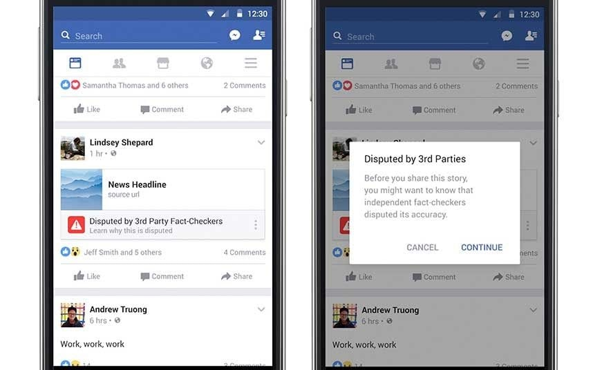

## Proposal 2

However, a designer at Facebook believes that there needs to be a different approach to content regulation. Their proposal is that content deemed problematic by third-party fact-checkers should be prevented from being shared on the platform altogether.

# 

# Questions

1. Which form of content regulation, Proposal 1 or Proposal 2, do you feel is better? Why?
   1. **Proposal 2**
   2. Facebook being a public institution, should play her role to share factual information to its users and the society that challenge the mainstream view.
2. Which form of content regulation, Proposal 1 or Proposal 2, do you think best preserves or promotes the [five rights and opportunities necessary for a democratic public sphere](https://cs50.harvard.edu/college/2020/fall/labs/10/lecture/#five-rights-and-opportunities-for-a-democratic-public-sphere)?
   1. Which proposal best preserves or promotes Rights? Why?
3. **Proposal 1**
4. This allows citizens to to participate in public discussion and also giving sense to the reader as how the content is. The right to expressive liberty is important not only for the freedom of the individual, so that he or she is not censored, but also for democracy itself. It enables citizens to bring their ideas into conversation with one another, and to criticize and hold accountable those who exercise power.
   1. Which proposal best preserves or promotes Opportunity for Expression? Why?
      1. **Proposal 1**
      2. Like the right, the warning exist, but the news should as well be shared to enable participation in public discussion. “Not only should we be free of censorship but we should have fair opportunity to participate in public discussion.”
   2. Which proposal best preserves or promotes Access? Why?
      1. **Proposal 2**
      2. The post should prevented from being shared as relates to the benefit of the society. With that, each person should have good and equal access to quality and reliable information on public matters. Effective participation in decision making on public matters requires being informed.
   3. Which proposal best preserves or promotes Diversity? Why?
5. **Proposal 2**
6. By sharing factual news, enhances the better chance of society to grow. So, each person will have good and equal chances to hear a wide range of views. We need access to competing views in order to have a more informed and reasoned position.
   1. Which proposal best preserves or promotes Communicative Power? Why?
      1. **Proposal 2**
      2. Fake news should be prevented from being shared so that citizens may have good and equal chances to explore interests and ideas in association with others, and through these associations, to develop new concerns that challenge the mainstream view.